**Example of Game Theory in Economics**

By investing in the stock market, you become a gambler. You have invested your money in a business that knows you will either make or lose money, but you don't know what. The company needs your investment to be successful. The decisions a company makes will either raise or lower the stock price, which will determine its future success. Shareholders do not know what decisions the company makes, and the company does not know what decisions shareholders make.

 Collusion and game theory

[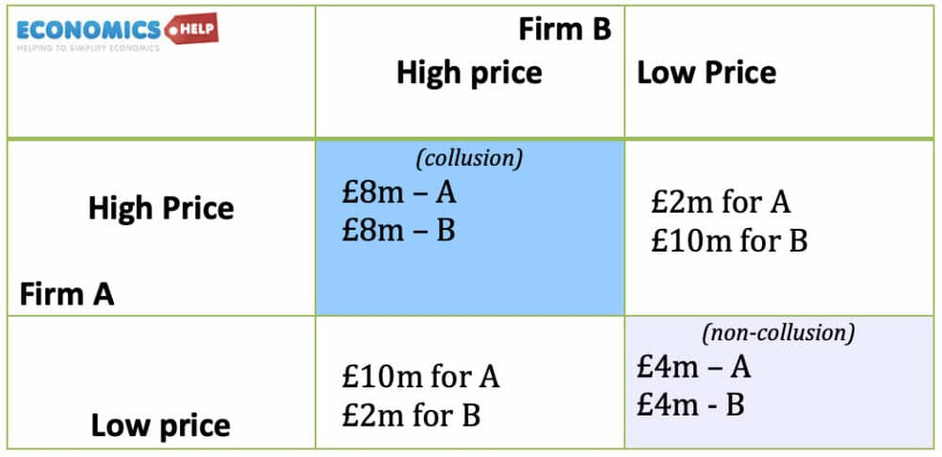](https://www.economicshelp.org/wp-content/uploads/2021/12/game-theory-collusion.jpg)

If a company is competitive and sets a low price, both will earn £ 4m. If you collude with  
and set a high price, the prize will be doubled to £ 8m.  
However, if Company A falls below the collusion price and sets a low price during the collusion, it can sell more. In this case, Company A takes advantage of both. Company B has a high price, so the price is high, but Company A also sells in large quantities because it is lower than its competitors. In this case, Company A earns only £ 10m and Company B earns only £ 2m.  
Therefore, Company B is unlikely to keep prices high and the market will set prices low again. The best result for a  
company is collusion (high price, high price).  
Game Theory: Game of Deterrence  
When a new company enters the market, the reward depends on whether the existing company fights or accepts. If the incumbent fights, both get 0. If they do not fight, the incumbent gets 1 and the participants get 2.  
Therefore, the balance is that the new company will enter and the incumbent will accept it.  
However, if the incumbent can pose a credible threat of fighting, it may be possible to convince the candidate to be off limits. You can do this by investing in additional capacity, which will bring greater profits in price competition. This prevents intrusion. Monopoly never uses this, but it prevents intrusion.  
Game Theory and Twisted Demand Curve

Game Theory can be used for pricing strategies

In liogopoly , companies can choose to lower, raise, or keep static. The  
twisted demand curve model suggests that the most likely result is price stability.

[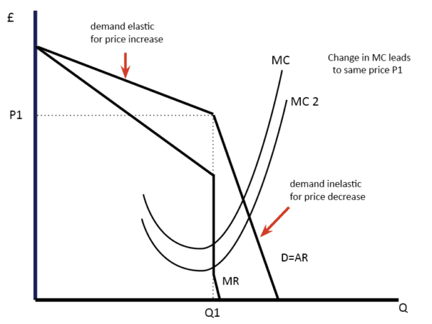](https://www.economicshelp.org/wp-content/uploads/2012/08/kinked-demand-curve.png)

When a company raises a price, other companies do not, so demand drops significantly. (Demand is flexible)  
When a company lowers its price, it gains market share. Other companies don't want to allow it. That's why they lower prices. Basically, it causes a price war that everyone loses.  
Therefore, in oligopoly, an important feature of corporate decision-making is the effect of interdependence. The decisions of one company have a big impact on others.

War vs Peace

[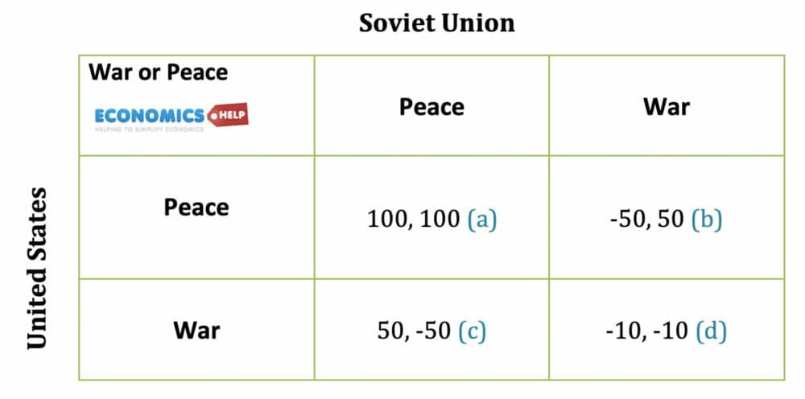](https://www.economicshelp.org/wp-content/uploads/2021/12/war-or-peace.jpg)

In this case, the best result for both parties is Peace, Peace (a)-Both get 100  
However, if you suspect a war may occur, it is advisable to attack first. Because if you attack first and start the war, you will get 50 and the loser will get -50. If there is tension between the two and you do not trust the other, it may encourage one country to start a war and deviate from the best strategy for both.

# Example of Game Theory In The Game Of Football

  From the moment Malcolm Butler made an amazing interception at the end of the Super Bowl XLIX, I'm always a little angry that many are screaming "Pete Carroll has ruined the game." Was standing up. By not giving the ball to Marshawn Lynch. But game theory explains why throwing the ball was probably the right decision.

During the 2017 regular season in the NFL, the passing and rushing attempts were as follows:

*Passing: 17,488 attempts, 114,870 yards, 6.57 average*

*Rushing: 13,753 attempts, 56,172 yards, 4.08 average*

 attacks and defenses. It's a concept that can be implemented in, but when we get to the most basic discussion, an attack will occur or will occur. Therefore, if your team goes through many passes, you need to prepare defenses to defend the passes. But in turn, aggressive playcallers know that defense tries to prevent them from succeeding in the air, so they should run. However, the defender must be aware of this and be aware of the execution. It also works in the opposite direction of a heavy-running team, becoming a circle, which is the game theory in football.

Game theory is one of the reasons why play action paths usually work well. It's a game, whether it's a typical dropback play action, a play action bootleg, or an RPO (Lampad Option), which has made the majority of NFL games in recent years. Offenses look great, so they don't just perform play action passes.  
In  
defense, britting is a tool that can be used to thwart large-scale transit crimes.  
Blitz calls can often result in more sack, which can take the offense out of rhythm or put it behind the chain, making it difficult to convert the first down and continue the drive. , May help your own offense in field positions.

But in great quarterbacks like Drew Brees and Tom Brady, taking the game theory in your hands, finding the electric shock and moving the ball from your hand to the right receiver will give you a regular advantage. I can. Brady and Breeze have many years of experience and have seen everything. Therefore, defenses are unlikely to overwhelm them with electric shock attacks. And young and athletic quarterbacks like Carson Wentz have a natural ability to get out of the electric shock.  
The excellent quarterback electric shock capability is just one of the reasons why strong defense makes defense much easier and more difficult to attack. Elly Tran Defender can force the attack into the third longest situation. This helps in game theory, where you can play passes to get stops and get your attacks back on the field. Of course, britting is still the ace of the sleeves and can be torn by defending with an elite front.

Look at the teams that have added excellent young running backs in recent years. Selected as one of the top 10 drafts by Rams, Jaguar, Cowboys and more. Todd Gurley, Leonard Fournette and Ezekiel Elliott all not only make the ball run well, but also pose a running threat, forcing more players into the box in the defense. The presence of stud runners like these guys can not only help the running game, but also help the pass game further as the defense needs to focus on the running back when he is the best player. ..

Good play callers are great, but game theory isn't that complicated. For example, if you are only thinking of calling play for an attack, you should call the play that is most likely to give your team a positive result. But you're not running against the air-you also have the opposite defense making decisions, and it's going to be a bit of a chess game.

Super Bowl XLIX provided a perfect example of game theory in real time in just minutes. After the Seahawks reached the 5-yard line through Jermaine Kears' spectacular wobble catch, it was 1:06 and there was a time-out-end the ball if they could pass the interfering pass. More than enough time to put it in the zone  
On the first down, they ran the ball with Marshawn Lynch. Marshawn Lynch almost entered, but stumbled on the one-yard line. In the situation where Seattle had only one timeout, the Patriots obviously didn't just try to stop the run, as the pass was a very viable option. They seemed to be in the end zone, but there was still time and the clock was ticking. Almost everyone expected Bill Belichick to time out and buy time for Tom Brady and offense-Chris Collinsworth at the NBC show, the Patriots touching down to the Seahawks to regain the ball. I even suggested it might be.

Belichick isn't credited for it because people like negatives, but he deserves praise for waiting for it and forcing Seattle's hand. When Lynch was tackled shortly before the goal line, there was less than 30 seconds left as the Seahawks were set for the second down game with 1:00 left. With only one time-out left, the Seahawks had to pass two of the remaining three downs and even have time to play four. Belichick forced her hand.

New England was crammed to stop the run after Lynch was about to play in the previous game-they didn't allow Lynch to run on the ball to win the expected game. bottom. The Patriots are packed with as many punches as people would say they would have been in if Lynch had just handed the ball. Perhaps Lynch was crammed and his team took the final time-out to let the Patriots know that the two passes would almost certainly come

While the Patriots were playing the run, they also made a perfect call to stop the quick pass they saw in the movie and practiced throughout the week (Butler did not stop). The plunged receiver, Butler, jumps in and allows you to create one of the biggest plays in NFL history. If you have any criticisms about the Seahawks playcall, it should be the type of pass game designed (although the wisdom is 20/20, which is easy to see after the game has happened).  
  
Belichick and his team have to weigh their actions against the actions of other players and quickly analyze their best strategies in the hope of winning the situation and the game. Was placed in. Carol and his team did the same  
The Seahawks knew that the Patriots wouldn't have two runplays when they were running the clock, so they decided to catch them trying to pass the pass in second place. There was only one winner, but it was played in front of me.  
  
A perfect example of soccer game theory on the most spectacular stage of the game.

**Example of game theory in Oligopoly**

Game Theory is a specific way to analyze social phenomena and processes. This is one of the possible ways to interpret human actions and decisions in conflict or partial conflict situations. All of these are situations where the final solution depends not only on the decision of one party, the player making the decision, but also on the decisions of the other participants. These behaviors are interdependent, influencing each other and influencing the end result of the decision-making process. One form of market structure is oligopoly. It's a market where only a few companies compete, and their products can be differentiated, but they don't have to. Another important feature of the oligopolistic market is the barriers to entry for new companies. The monopoly and profitability of an oligopolistic company depends in part on the interaction between the companies. With their cooperation, businesses can charge far above marginal costs and therefore make significant profits. When they compete aggressively, it leads to lower prices and, as a result, lower profits. Why do companies work together in some oligopolistic markets and compete fiercely in others? How do companies set prices? The answers to these questions are obtained through the application of game theory, which has contributed significantly to the analysis of the strategic decisions of oligopolistic companies.  
Oligopoly is the dominant form of market structure. This is one of the intermediate forms of pure competition and pure monopoly. The oligopolistic market is characterized by the fact that there are only a few companies and the entry of new companies is limited. Products can be differentiated (as in the automotive industry), but they don't have to be (as in the steel industry). The degree of monopoly of a company depends in part on the interactions that exist between the companies. While companies are cooperating in some oligopolistic industries, they are actively competing in others, resulting in low profits. When making decisions in an oligopolistic market, you need to take into account possible reactions from your competitors. It is also assumed that the company as the subject acts rationally, that is, thinks about the consequences of the action. Game theory is widely used in oligopolistic market situation surveys. In fact, many of the central problems of oligopoly depend on the strategic interrelationships that exist between market participants. The question of strength of interaction above, where the game theory model provides the answer, is of particular importance. For the purposes of this paper, to simplify the analysis of the oligopolistic market, consider the case of duopoly or when there are only two companies in the market. Every company has only one competitor to consider when making a decision. Using the example of duopoly (Company A and Company B), we show how a company gains a market advantage by choosing price as a strategic variable.  
Game theory states that in all situations where the strategic interests of a game participant partially or completely conflict, and the end result is the actions and decisions of one player, as well as the other participants in the game.

**The reference**

1. Economics.com
2. Science Direct
3. WolfSport.com (by david chappine)
4. Carmichael F.: A Guide to Game Theory, Prentice Hall, Yew Jersey, USA, 2005